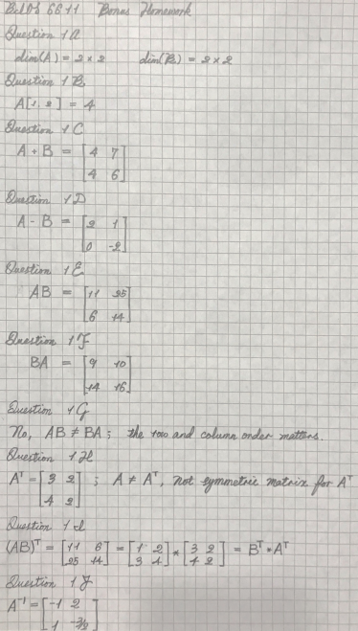

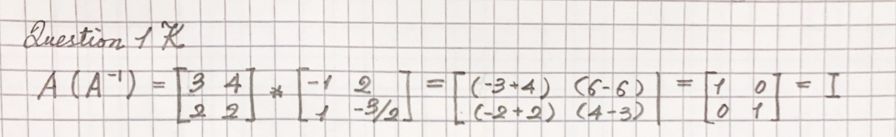

Question2A

The horizontal line is the principal component, because the horizontal line represents the largest variance for the data set.

Question2B

In the triangle example, the only principal component is the horizontal line; but the second eigenvalue is perpendicular to the principle component. Hence the data can be plotted on two orthogonal lines.

Question2C

The third eigenvalue was zero, because the data is on a hyperplane, for the higher dimension. In this example the plane with the triangles in an oval is a 2D hyperplane in a 3D space. Hence the third eigenvalue is the height as the value of zero.

Question2D

The dimension of the data set was reduced from 50 to 4 fill the blanks.